**HIGH COOLING MIST FANS:**

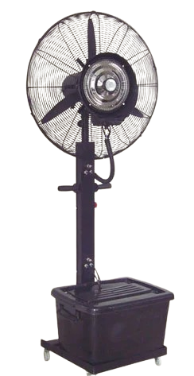

**Price: 15,400.00**

The High Cooling Mist Fan is a revolutionary cooling solution that combines powerful airflow with a fine misting system, providing unparalleled cooling relief in hot and dry environments. With its advanced evaporative technology, this fan lowers temperatures by up to 30°F, making it ideal for outdoor and indoor spaces, such as patios, gardens, and warehouses. Its durable construction, adjustable misting system, and energy-efficient design ensure effective and eco-friendly cooling, making it perfect for those seeking a reliable and refreshing cooling solution.

**Key features of high cooling mist fans include:**

* **Misting Function:** These fans have built-in water misting systems that release a fine mist into the air, which helps lower the surrounding temperature by evaporating the water.
* **Adjustable Fan Speed:** Most high cooling mist fans offer adjustable fan speeds to allow users to control airflow based on their needs.
* **Cooling Capacity:** They provide enhanced cooling, especially in outdoor or hot environments, by combining evaporative cooling with air movement.
* **Water Tank:** These fans come with a water reservoir (tank) that supplies water for the misting feature. Larger tanks provide longer misting durations without needing frequent refills.
* **Energy Efficiency:** Many high cooling mist fans are designed to be energy-efficient, making them cost-effective for prolonged use, especially compared to air conditioners.
* **Portability:** These fans are often portable, with designs that make them easy to move from one location to another, ideal for outdoor settings like patios or events.
* **Oscillation Feature:** Some models include an oscillating function, allowing the fan to spread the mist and cool air more evenly across a wider area.
* **Humidity Control:** Some models allow users to adjust the level of mist to control the amount of humidity in the environment, helping to avoid excessive moisture buildup.
* **Quiet Operation:** Many high cooling mist fans are designed to operate quietly, ensuring minimal disturbance while providing comfort.
* **Durable Construction:** These fans are typically made with weather-resistant materials, making them suitable for both indoor and outdoor use.